example2_dflow.yaml

nodes:
n0:
assignedTo: 0
deps: []
accessTo:
- [n1, 30]
- [n3, 10]
release: 0
traceName: N1-trace
n1:
assignedTo: 0
deps: [n0]
accessTo:
- [n2, 20]
release: 0
traceName: N2-trace
n2:
assignedTo: 0
deps: [n5, n3, n1]
accessTo:
- [n2, 10]
release: 0
traceName: N3-trace
n3:
assignedTo: 1
deps: [n0]
accessTo:
- [n2, 50]
release: 0
traceName: N4-trace
n4:
assignedTo: 2
deps: []
accessTo:
- [n5, 20]
release: 0
traceName: N5-trace
n5:
assignedTo: 2
deps: [n4]
accessTo:
- [n2, 50]
release: 0
traceName: N6-trace
numOfCores: 3
period: 1000000

# spec. arch Bostan

example2_dflow_NoTrace.yaml

nodes:
n0:
assignedTo: 0
deps: []
accessTo:
- [n1, 30]
- [n3, 10]
release: 0
procDemand: 27
memDemand: 2
nbTransactions: 2
#traceName: N1-trace
n1:
assignedTo: 0
deps: [n0]
accessTo:
- [n2, 20]
release: 0
procDemand: 43
memDemand: 10
nbTransactions: 10
#traceName: N2-trace
n2:
assignedTo: 0
deps: [n5, n3, n1]
accessTo:
- [n2, 10]
release: 0
procDemand: 20
memDemand: 8
nbTransactions: 8
#traceName: N3-trace
n3:
assignedTo: 1
deps: [n0]
accessTo:
- [n2, 50]
release: 0
procDemand: 22
memDemand: 2
nbTransactions: 2
#traceName: N4-trace
n4:
assignedTo: 2
deps: []
accessTo:
- [n5, 20]
release: 0
procDemand: 38
memDemand: 10
nbTransactions: 10
#traceName: N5-trace
n5:
assignedTo: 2
deps: [n4]
accessTo:
- [n2, 50]
release: 0
procDemand: 25
memDemand: 8
nbTransactions: 8
#traceName: N6-trace
numOfCores: 3
period: 1000000

# spec. arch Bostan
example2_dflow.yaml

La commande : cat /tmp/output_mia_15245.yaml (afficher le contenu du fichier)

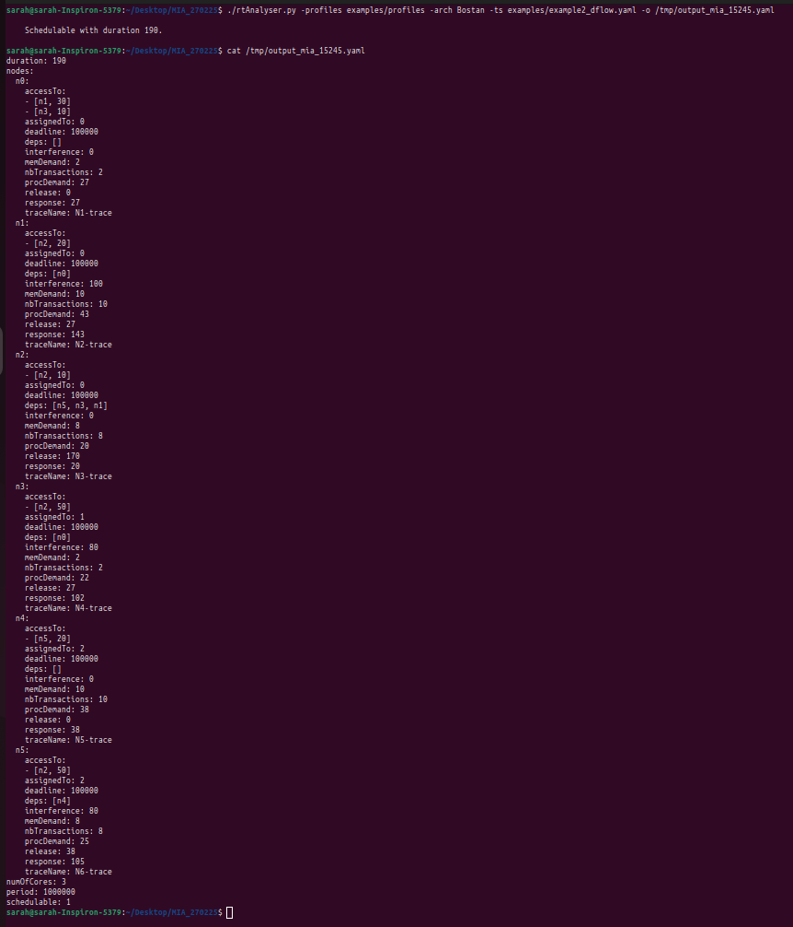

example2_dflow_NoTrace.yaml

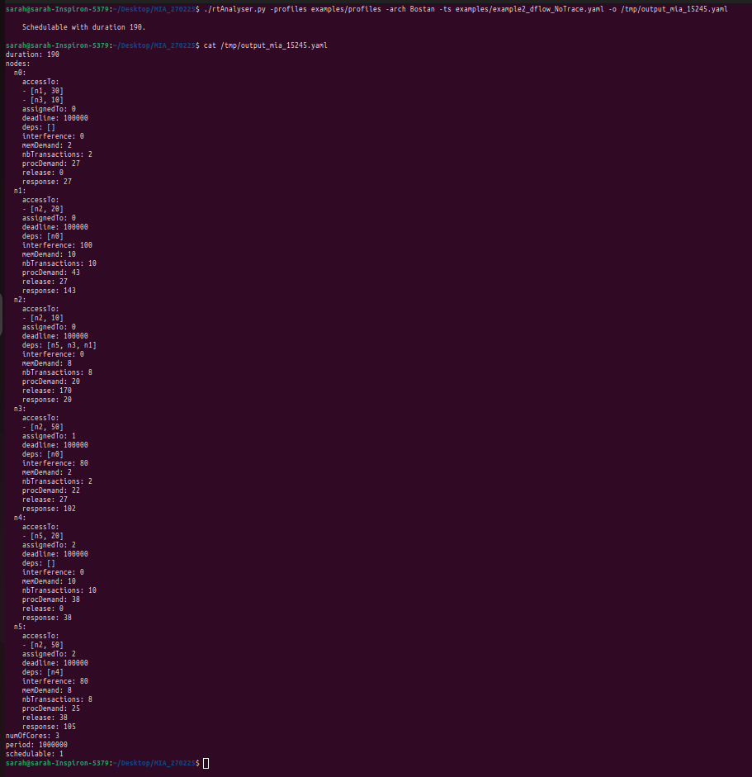

rtns2019_improved.yaml
N6:
assignedTo: 11
order: 0
traceName: N6_ex3
release: 0
deps: []
accessTo:
- [N9, 10]
deadline: 1000000
N7:
assignedTo: 11
order: 1
traceName: N7_ex3
release: 0
deps: [N6]
deadline: 1000000
N8:
assignedTo: 10
order: 4
traceName: N8_ex3
release: 0
deps: [N9, RX1]
deadline: 1000000
Copy2:
assignedTo: 10
order: 1
traceName: Copy2_ex3
release: 0
deps: [N2]
deadline: 1000000
EOT2:
assignedTo: 10
order: 2
traceName: EOT
release: 0
deps: [Copy2]
deadline: 1000000
RxAccesses:
RX1:
order: 0
accessTo: [[N8, 20]]
deps: [Copy1]
traceName: RX1_ex3
release: 0
assignedTo: -10
deadline: 1000000
RX2:
order: 1
accessTo: [[N5, 20]]
deps: [Copy2]
traceName: RX2_ex3
release: 0
assignedTo: -10
deadline: 1000000
schedulable: 1

# spec. arch Bostan
numOfCores: 12
deadline: 1000000
period: 1000000
nodes:
N1:
assignedTo: 0
order: 0
traceName: N1_ex3
release: 0
deps: []
deadline: 1000000
N10:
assignedTo: 0
order: 3
traceName: N10_ex3
release: 0
deps: [N3, EOT1]
deadline: 1000000
N3:
assignedTo: 1
order: 0
traceName: N3_ex3
release: 0
deps: []
accessTo:
- [N10, 10]
deadline: 1000000
N4:
assignedTo: 1
order: 1
traceName: N4_ex3
release: 0
deps: [N3]
deadline: 1000000
N5:
assignedTo: 0
order: 4
traceName: N5_ex3
release: 0
deps: [RX2, N10]
deadline: 1000000
Copy1:
assignedTo: 0
order: 1
traceName: Copy1_ex3
release: 0
deps: [N1]
deadline: 1000000
EOT1:
assignedTo: 0
order: 2
traceName: EOT
release: 0
deps: [Copy1]
deadline: 1000000
N2:
assignedTo: 10
order: 0
traceName: N2_ex3
release: 0
deps: []
deadline: 1000000
N9:
assignedTo: 10
order: 3
traceName: N9_ex3
release: 0
deps: [N6, EOT2]
deadline: 1000000

rtns2019_improved.yaml

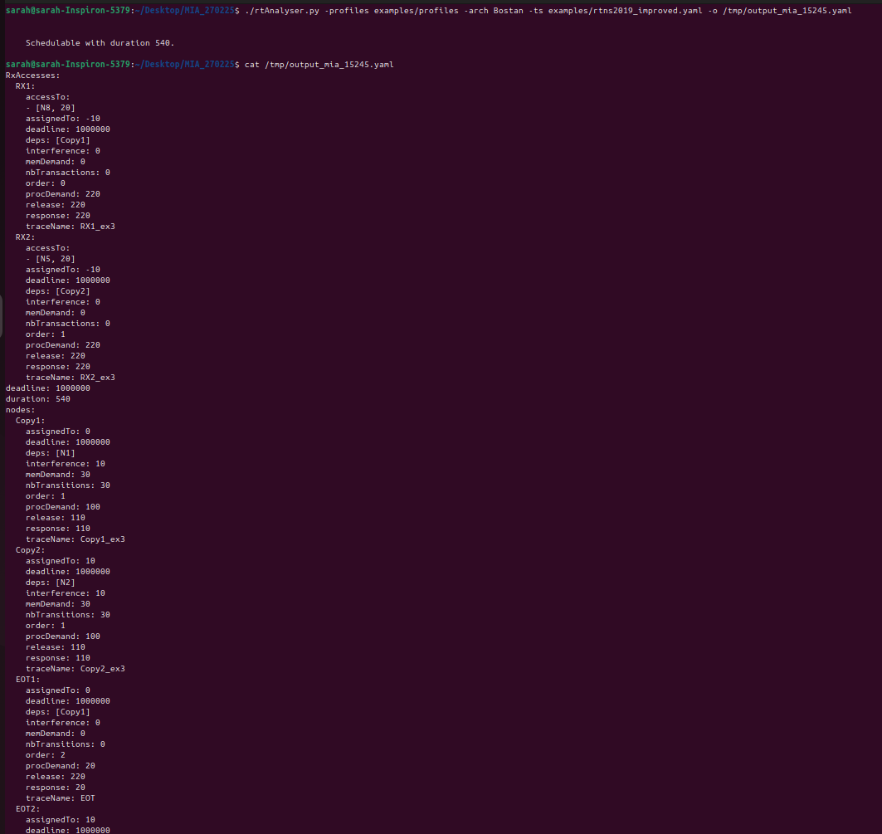
ect….

POUR UNE EXECUTION PLUS DETAILLEE

Il faut utiliser le mode EXPLAIN (-e) ou VERBOSE (-v) ou bien les deux afin d’afficher plus d’infos sur l’execution.

Test1 :

./rtAnalyser.py -profiles examples/profiles -arch Bostan -ts examples/example2_dflow.yaml -o /tmp/output_mia_15245.yaml -e

Test2 :

./rtAnalyser.py -profiles examples/profiles -arch Bostan -ts examples/example2_dflow.yaml -o /tmp/output_mia_15245.yaml -v

